Linear fn check : <https://gateoverflow.in/8294/gate-cse-2015-set-1-question-39?show=37120#c37120>

Emil post functional completeness : <https://gateoverflow.in/8294/gate-cse-2015-set-1-question-39?show=8532#a8532> [all the 5 steps]

Imp I always forget:-

1. IN S/R or J/K -> [TRICK : “When inputs are different, the Q (ouput) = whatever bit is in S/J”

If S or J = 0 & R or K =1 🡪 Q = S = 0 (RESET)

If S or J = 1 & R or K =0 🡪 Q = S = 1 (RESET)

------------------------------------------------------------

1. IN Booth’s Bit pair multiplier:- [TRICK: “Think 0 = +ve and 1 = -ve, so 01 = +1 and 10 = -ve”]

Initially take q-1 = 0

Then if bit pair = 0 1 🡪 +1 (ADD & ASR)

If Bit Pair = 1 0 🡪 -1 (SUB AND ASR)

Also remember the no.s are taken from LSB to MSB i.e q-1, q0, q1, q2 …, So while writing the recoded multiplier report answer from MSB to LSB (which is very natural)

------------------------------------------------------------------------------------------------

1. Overflow Expression : XYZ’ + X’Y’Z {VERY IMP} {X = MSB of 1st number, Y = MSB of 2nd number, Z = MSB of Result}

Note:-

* If opposite signed data added 🡪 Overflow Never Occurs
* If same signed data (X=Y) added and result (Z) is of different sign then definitely overflow occurred. Determine as:-
  + If X = Y = 1 & Z = 0 🡪 Means two negative no. added so result is negative. Hence take the carry and place it at the first and determine the result accordingly in 2’s complement form (Sign is negative, then convert entire no with 2’s complement method and output the result with sign)
  + If X = Y = 0 & Z = 1 🡪 Means two positive no. added so result is positive. No need to convert into 2’s completement form as it’s already +ve

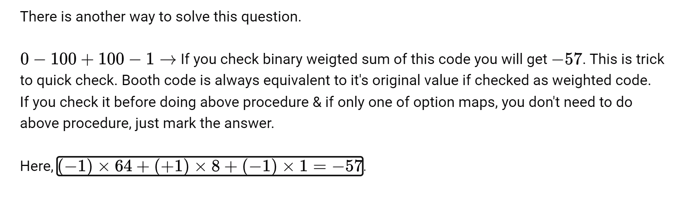

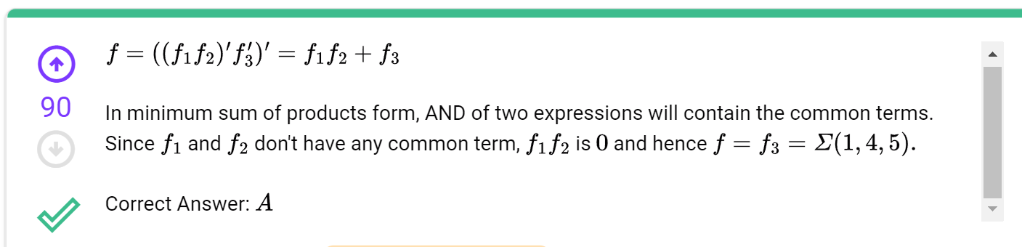

Must go through q: [Digital Logic: GATE CSE 2008 | Question: 8 (gateoverflow.in)](https://gateoverflow.in/406/gate-cse-2008-question-8)

[Digital Logic: prime implicants (gateoverflow.in)](https://gateoverflow.in/66719/prime-implicants) [Very good question]

OR AND(POS) realization is implemented by NOR gates

AND OR(SOP) is implemented by NAND

Do this: [Digital Logic: GATE CSE 2019 | Question: 50 (gateoverflow.in)](https://gateoverflow.in/302798/gate-cse-2019-question-50)

